Today we have implemented a nmos static inverter, using 2 transistors. The circuit presents an inverter obtained with M1 transistor and M2 transistor working as an resistance. The external load of this inverter is made up also with inputs of NMOS and the load has a character of capacitance

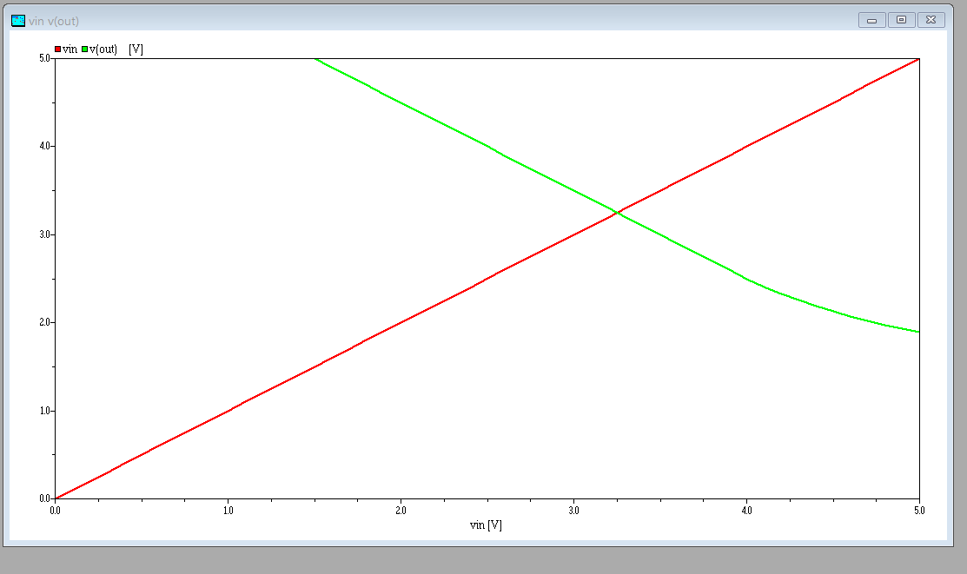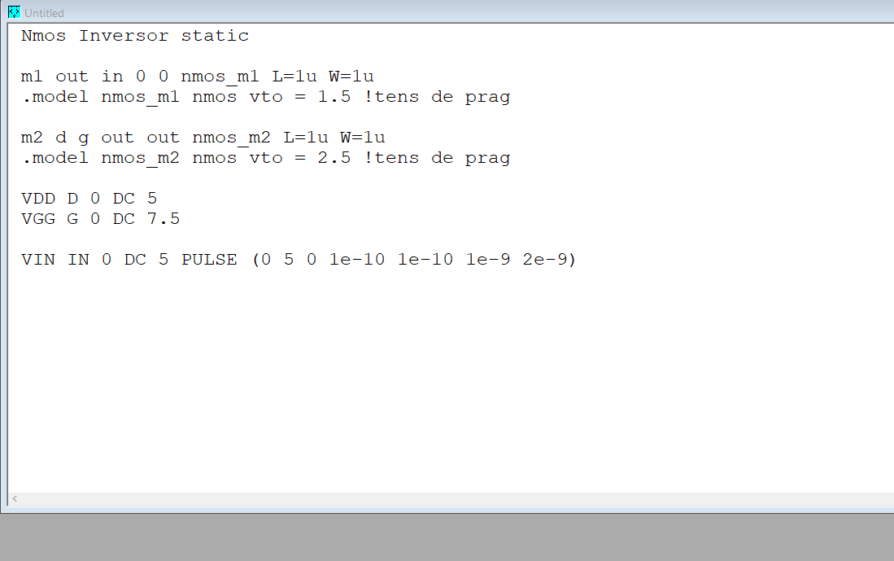

We have also realized a nand gate with NMOS transistors. It has two NMOS transistors on which we apply the inputs. Transistors are connected in series and we use M3 as a load resistance.

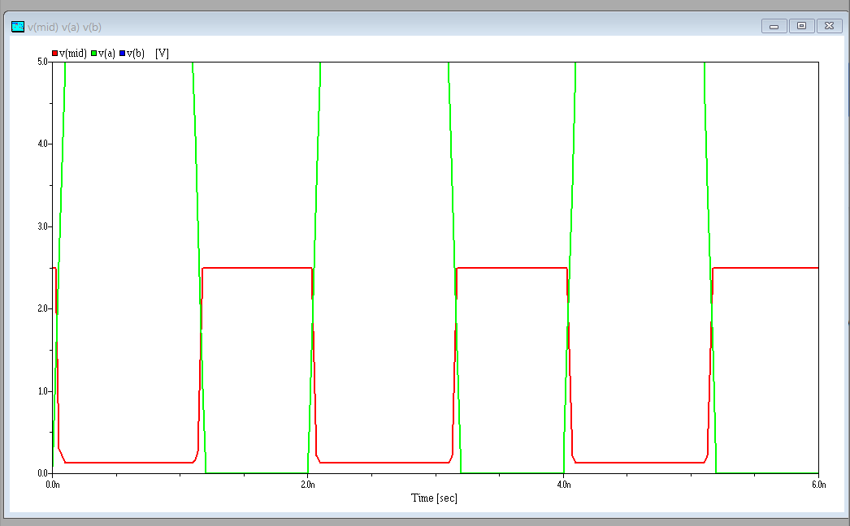

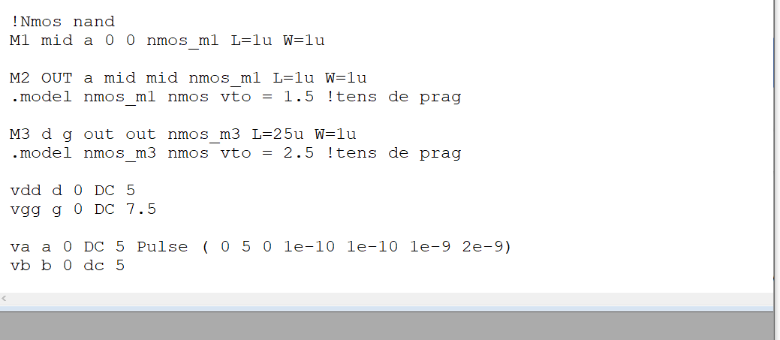

The nor gate with NMOS transistors is composed with parallel connection of the transistors on which the logic signals are applied.if both inputs have a low voltage applied, the transistor is in cut off stage and the output is high.

If at least one input has a high voltage, then the output voltage is close to 0

